

نفاذ رقمي للجميع (شعار مركز مدى)

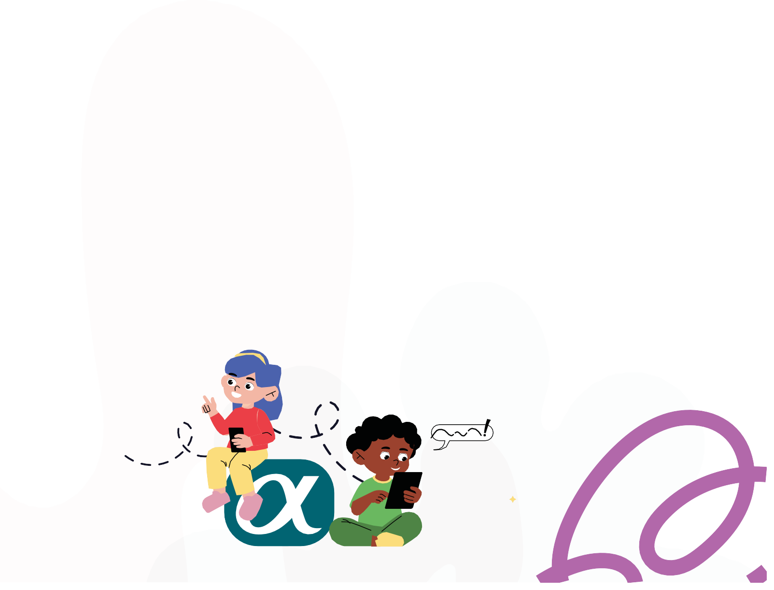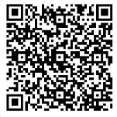

**ورش ﻋﻤﻞ ﻓﻲ اﻟﺒﺮﻣﺠﺔ**

**ﺗﺒﻲ ﺗﺘﻌﻠﻢ ﺑﺮﻣﺠﺔ؟**

**ﻣﺘﻌﺔ، إﺑﺪاع، اﺑﺘﻜﺎر**

# شعار مخيم مدى الصيفي (مخيم مدى الصيفي)ﻻ ﻳﻔﻮﺗﻚ اﻟﻤﺨﻴﻢ!

**اﻧﺖ ﻣﺒﺪع ﻣﻦ ذوي اﻹﻋﺎﻗﺔ؟ ﻋﻤﺮك ﺑﻴﻦ 10 و 15 ﺳﻨﺔ؟**

**ﺗﺤﺐ اﻟﺒﺮﻣﺠﺔ واﻟﺮوﺑﻮﺗﺎت واﻟﺬﻛﺎء اﻻﺻﻄﻨﺎﻋﻲ؟**

## ﻳﻌﻨﻲ ﻻزم ﺗﺸﺎرك ﻓﻲ:

**ﻣﺨﻴﻢ ﻣﺪى اﻟﺼﻴﻔﻲ ﻟﻸﺷﺨﺎص ذوي اﻹﻋﺎﻗﺔ 2025**

**”ﺣﻴﺚ ﺗﺘﺄﻟﻖ اﻟﻄﺎﻗﺎت اﻟﺸﺎﺑﺔ“**

اﻟﻤﻜﺎن: ﻣﺪى ﻻب، اﻟﻄﺎﺑﻖ اﻟﺴﺎﺑﻊ، ﺑﺮج اﻟﻨﺼﺮ )ب(

اﻟﻮﻗﺖ: ﻣﻦ 09:00 ﺻﺒﺎﺣًﺎ ﺣﺘﻰ 01:00 ﻇﻬﺮًا

### ﻣﻮاﻋﻴﺪ اﻟﻤﺨﻴﻢ:

اﻟﻤﺠﻤﻮﻋﺔ اﻷوﻟﻰ )ﻟﻠﺒﻨﻴﻦ:( 8-6 ﻳﻮﻟﻴﻮ اﻟﻤﺠﻤﻮﻋﺔ اﻟﺜﺎﻧﻴﺔ )ﻟﻠﺒﻨﺎت:( 15-13 ﻳﻮﻟﻴﻮ

اﻟﻤﺠﻤﻮﻋﺔ اﻟﺜﺎﻟﺜﺔ: )اﻟﻤﺒﺪﻋﻴﻦ اﻟﺼﻢ:( 19-17 أﻏﺴﻄﺲ

**ﻟﻠﺘﺴﺠﻴﻞ،** [**اﺿﻐﻂ ﻫﻨﺎ**](https://forms.office.com/Pages/DesignPageV2.aspx?subpage=design&token=c7df2fcb1b5b4496bc998d5e1d85f2ab&id=VZfrSrGmpEOK8rC9i5Js_qmweYNGNupNsx-64DDB8_lUOUxHU0xTVEhaWkJFV1hBQVRYSVdUQ0VTSi4u)

**أو اﻣﺴﺢ رﻣﺰ اﻻﺳﺘﺠﺎﺑﺔ اﻟﺴﺮﻳﻌﺔ**

**ﺗﻌﻠﻢ ﺗﻔﺎﻋﻠﻲ**



**أنشطة**

**جماعية**

**ﻟﻺﺳﺘﻔﺴﺎر:** 44594060

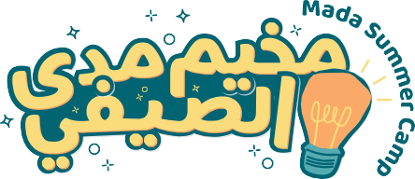

Mada tagline (Digital Access for All)Want to learn programming?



**Don’t miss the camp!**

 **Are you a creative youth with a disability? ** **Aged between 10 and 15?**

 **Passionate about programming, robotics, and artificial intelligence?**

## Then you must join:

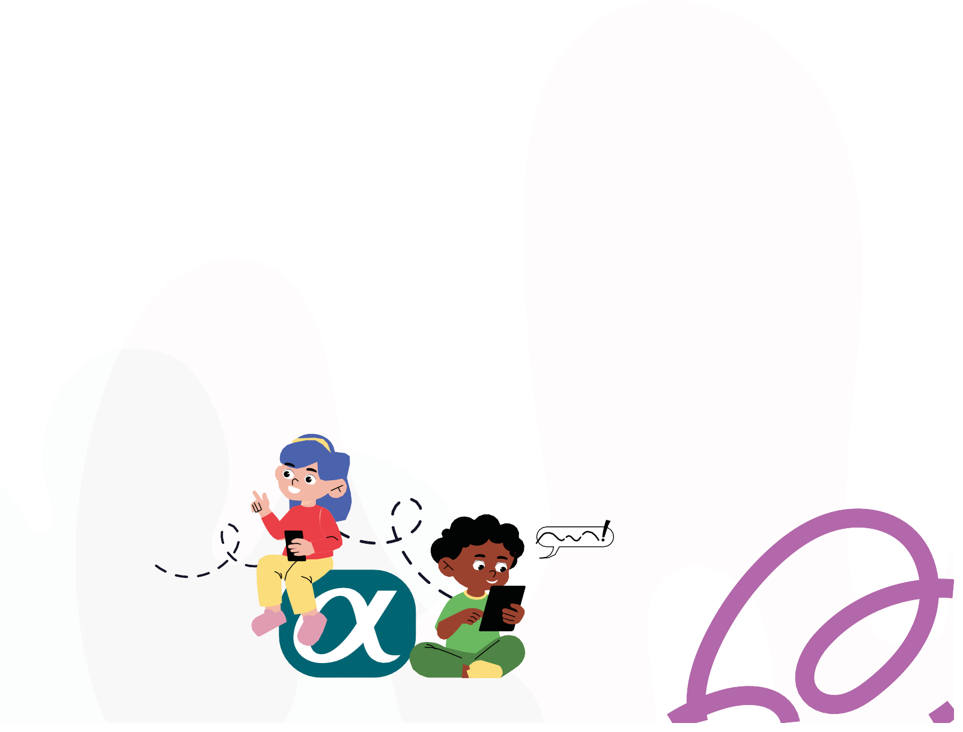

Mada Summer Camp for Persons with Disabilities 2025

“Where young energies shine”

Location: Mada Lab, floor 7, Al Nasr tower B

Time: 09:00 AM to 01:00 PM

### Camp sessions:

Group 1 (for Boys): July 6-8

Group 2 (for Girls): July 13-15

Group 3 (Deaf innovators): August 17-19

**For Registration,** [**click here**](https://forms.office.com/Pages/DesignPageV2.aspx?subpage=design&token=c7df2fcb1b5b4496bc998d5e1d85f2ab&id=VZfrSrGmpEOK8rC9i5Js_qmweYNGNupNsx-64DDB8_lUOUxHU0xTVEhaWkJFV1hBQVRYSVdUQ0VTSi4u) **or scan the below QR code**

**Interactive**

**Learning**

**Coding**

**Workshops**

**For inquiries:** 44594060

Power in Teams

****Fun, creativity, and Innovation